**Example 1: -**

Class: -BSAI-2A **OOP Lab Task** Reg no: -22108190

***Code*: -**

#include<iostream>

using namespace std;

void duplicate (int& var1, int& var2, int& var3)

{

var1*=2;

var2*=2;

var3*=2;

}

int main()

{

int a=1,b=3,c=7;

duplicate(a,b,c);

cout<<"a="<< a <<", b=" << b <<", c=" << c;

return 0;

}

***Output: -***

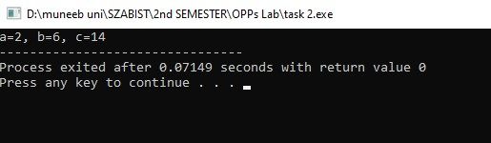

**Example 2: -**

***Code: -***

#include<iostream>

using namespace std;

int main()

{

int first, second;

int *myptr;

myptr =&first;

*myptr = 10;

myptr = &second;

*myptr = 20;

cout <<"First Value is" <<first<<endl;

cout <<"Second Value is" <<second<<endl;

return 0;

}

***Output: -***

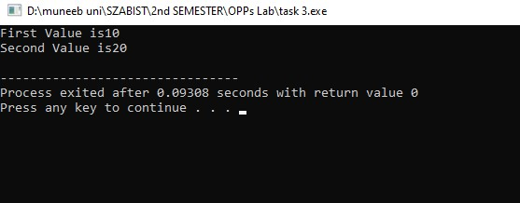

**Example 3: -**

***Code: -***

#include <iostream>

#include <cstring>

using namespace std;

int main() {

const int MAX_LENGTH = 100;

char inputString[MAX_LENGTH];

cout << "Enter a string: ";

cin.getline(inputString, MAX_LENGTH);

int length = strlen(inputString);

// Create a pointer to the last character of the string

char* reversePointer = inputString + length - 1;

cout << "Reversed string: ";

while (reversePointer >= inputString) {

cout << *reversePointer;

reversePointer--;

}

cout << endl;

return 0;

}

***Output: -***

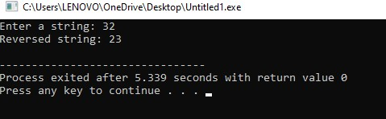

**Lecture 1 Ended**